**3rd Semester/ Project Report**

**Project Name**:BOOKING SYSTEM FOR HOTEL

****

**Project Advisor: SHAHBAZ QADEER**

**Name :** Taha Ahmed (f2023266528)

**Name :**Abdul Manan(f2023266541)

**Session**

**Fall 2023**

**University of Management and Technology**

**C-II Johar Town Lahore Pakistan**

**Dedication**

**We want to dedicate this to our parents, professors and my institution who always guided me throughout my life.**

## 

**Final Approval**

* **Head of Department**  \_\_\_\_\_\_\_\_\_\_\_\_\_\_\_\_\_\_\_\_\_\_

Department of Informatics & Systems

School of Systems & Technology

UMT Lahore

* **Director (Final Year Projects-CS)** \_\_\_\_\_\_\_\_\_\_\_\_\_\_\_\_\_\_\_\_\_\_

Department of Computer Science.

School of Systems & Technology

UMT Lahore

* **Supervisor** \_\_\_\_\_\_\_\_\_\_\_\_\_\_\_\_\_\_\_\_\_\_
* Department of Informatics & Systems.
* School of Systems & Technology

UMT Lahore

* **Co-Supervisor** \_\_\_\_\_\_\_\_\_\_\_\_\_\_\_\_\_\_\_\_\_\_

**Acknowledgment**

We would like to express our sincere gratitude to everyone who contributed to the successful development of our **Hotel Booking System**.

First and foremost, we extend our heartfelt thanks to our **project supervisor/instructor** for their continuous guidance, valuable insights, and constructive feedback throughout the development process. Their expertise has been instrumental in shaping this project.

We also appreciate the **support from our peers and colleagues**, who provided valuable suggestions and encouragement that helped refine our system.

**Project Title:**

Booking system for hotel

**Objective:**

The objective of the **Hotel Booking System** is to develop a user-friendly, efficient, and automated platform that allows customers to **search, book, and manage hotel reservations** seamlessly. It aims to **streamline hotel operations**, reducing manual workload and enhancing customer experience by providing **real-time availability, secure payments, and automated booking confirmations**.

**Undertaken by:**

Taha Ahmed Qureshi (F2023266528)

Malik Abdul Manan (F2023266541)

**Supervised by:**

Shahbaz qadeer

**Starting Date:**

2 feb 2025

**Completion Date:**

9 feb 2023

**Tools Used:**

Development Stack: MERN (MongoDB, Express.js, React.js, Node.js). User Interface: Material-UI, Bootstrap, Figma, Canva

Frontend: HTML, CSS, JavaScript.

Backend: Node.js and Express.js.

Database: MongoDB.

Image Handling: Cloudinary.

**Operating System :**

all opeating systems

**Documentation:**

Software Requirement specification

**Project Overview**

The Hotel Booking System is a software engineering project aimed at

developing a web-based application for managing hotel room

bookings, guest information, and reservation processes. The system

will provide a user-friendly interface for hotel staff to manage

bookings, and for guests to make online reservations.

**Project Objectives**

1. Design and develop a web-based hotel booking system that

allows guests to make online reservations and hotel staff to

manage bookings efficiently.

2. Provide a user-friendly interface for guests to search and book

available rooms, and for hotel staff to manage room inventory,

rates, and reservations.

3. Implement a secure payment gateway for online transactions.

4. Develop a reporting system to generate reports on booking

trends, revenue, and guest information.

5. Ensure the system is scalable, reliable, and maintainable.**Functional Requirements**

1. **Guest Module**

•

Search and book available rooms

•

View room details, rates, and availability

•

Make online payments

•

View and manage booking history

2. **Hotel Staff Module**

•

Manage room inventory, rates, and availability

•

Create and manage bookings

•

View and manage guest information

•

Generate reports on booking trends, revenue, and guest

information

3. **Admin Module**

•

Manage user roles and permissions

•

Configure system settings and parameters

•

Monitor system performance and security

**Non-Functional Requirements**1. **Security**

•

Implement secure authentication and authorization

mechanisms

•

Use encryption for sensitive data

•

Regularly update and patch the system to prevent

vulnerabilities

2. **Usability**

•

Design an intuitive and user-friendly interface

•

Ensure the system is accessible on various devices and

browsers

3. **Performance**

•

Ensure the system can handle a high volume of

concurrent users

•

Optimize database queries and system resources

4. **Scalability**

•

Design the system to scale horizontally and vertically

•

Use cloud-based infrastructure to ensure scalability and

reliability

**Technical Requirements**1. **Front-end**

•

Use HTML5, CSS3, and JavaScript for client-side

development

•

Utilize a front-end framework such as React or Angular

2. **Back-end**

•

Use a server-side programming language such as Java or

Python

•

Utilize a web framework such as Spring or Django

3. **Database**

•

Use a relational database management system such as

MySQL or PostgreSQL

•

Design a database schema to store hotel, room, and guest

information

4. **Payment Gateway**

•

Integrate a secure payment gateway such as PayPal or

Stripe

**Project Timeline**

1. **Requirements Gathering**: 2 weeks

2. **System Design**: 4 weeks3. **Front-end Development**: 8 weeks

4. **Back-end Development**: 12 weeks

5. **Testing and Debugging**: 8 weeks

6. **Deployment and Maintenance**: 4 weeks

**Project Team**

1. **Project Manager**: responsible for overseeing the project and

ensuring it is completed on time and within budget

2. **Software Engineers**: responsible for designing and developing

the system

3. **Quality Assurance Engineers**: responsible for testing and

debugging the system

4. **Technical Writer**: responsible for creating user documentation

and guides

**Budget**

The estimated budget for this project is $200,000, broken down into:

1. **Personnel**: $120,000 (60% of total budget)

2. **Software and Tools**: $30,000 (15% of total budget)

3. **Infrastructure**: $20,000 (10% of total budget)4. **Miscellaneous**: $30,000 (15% of total budget)

**User Requirements:**

User requirements focus on what the end users need or expect from the system. These can be divided into functional and non-functional requirements.

1. **Functional Requirements:**

**User Registration & Authentication**:

* + - Users (both guests and hotel staff) should be able to create accounts, log in, and manage their profiles securely.

**Search & Filter**:

* + - Customers should be able to search available rooms based on different criteria like dates, room types, price, amenities, etc.

**Room Booking**:

* + - Users should be able to view room availability, book rooms, and select services (e.g., spa, meals).

**Payment Processing**:

* + - A secure system to handle payment for bookings, including support for multiple payment methods (credit/debit cards, PayPal, etc.).

**Booking Confirmation**:

* + - After booking, the user receives a confirmation email or SMS with booking details.

**Booking Management**:

* + - Users (guests and hotel staff) can modify, cancel, or reschedule bookings within allowed timeframes.

**Non-Functional Requirements:**

* **Usability**:

The system should be user-friendly, with an intuitive UI/UX design.

* **Performance**:

The system should load quickly and handle high volumes of traffic (especially during peak booking times).

* **Security**:

The system must protect user data, including personal and payment information.

* **Scalability**:

As the hotel expands, the system should be able to accommodate more rooms, customers, and traffic without performance degradation.

**System Requirements:**

System requirements are technical specifications that describe the environment in which the system will operate, the hardware and software needed, and its interactions with other systems.

1. **Hardware Requirements:**

**Server**: A robust server to host the system, with sufficient CPU, RAM, and storage space to handle the expected traffic and data load.

**Database Server**: A reliable database system (e.g., MySQL, PostgreSQL) to store guest information, booking records, payments, room availability, etc.

1. **Software Requirements:**

**Operating System**: Server OS (e.g., Linux, Windows Server) and client-side OS (Windows, macOS, iOS, Android).

**Database Management System (DBMS)**: For storing customer and booking data.

1. **Network Requirements:**

**Internet Access**: A stable internet connection for cloud-based systems or data communication.

**Security Protocols**: Use of SSL/TLS encryption for secure online payments and customer data

.

1. **Backup and Recovery:**

**Data Backup**: Regular backups of customer data and booking information.

**Disaster Recovery**: Plans in case of system failure or data loss.

1. **Integration Requirements:**

**Payment Gateway Integration**: For processing payments (e.g., PayPal, Stripe, credit/debit cards).

**Third-Party APIs**: For checking availability, integrating with travel agents, or even providing reviews.

**ERD DIAGRAM OF BOOKING SYSTEM OF HOTEL:**

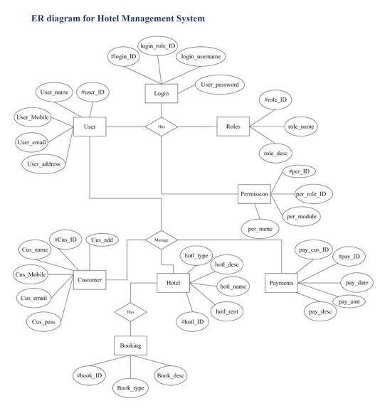

**USE CASE DIAGRAM OF BOOKING SYSTEM OF HOTEL:**

**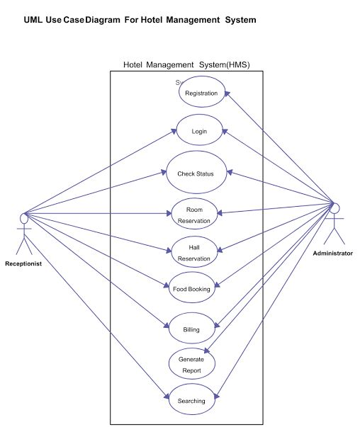**

### ****USE CASE :****

### ****1. Customer Booking Process****

Actors: **Guest (Customer), System**

* Search available rooms
* Select room
* Make reservation
* Make payment
* Cancel reservation

### ****2. Admin Room Management****

Actors: **Administrator**

* Add new rooms
* Update room details
* Remove rooms
* Manage room availability

### ****3. User Management****

Actors: **Administrator, Guest**

* Register new user
* Login/logout
* Update user profile
* Reset password

### ****4. Payment Processing****

Actors: **Guest, Payment Gateway**

* Select payment method
* Make payment
* Generate invoice
* Refund process

### ****5. Check-in and Check-out****

Actors: **Receptionist, Guest**

* Verify reservation
* Assign room key
* Update check-in status
* Process check-out

### ****6. Hotel Staff Management****

Actors: **Administrator, Hotel Staff**

* Add staff members
* Assign roles
* Update work schedule

### ****7. Feedback & Reviews****

Actors: **Guest, Administrator**

* Write review
* Rate hotel service
* Respond to reviews

### ****8. Promotions & Discounts****

Actors: **Administrator, Guest**

* Create discount offers
* Apply promo codes
* Notify users about promotions

### ****9. Reporting & Analytics****

Actors: **Administrator**

* Generate revenue reports
* View booking trends
* Analyze customer behavior

### ****10. Notification System****

Actors: **System, Guest**

* Send booking confirmation
* Send reminders
* Notify about cancellations

**STATE DIAGRAM:**

**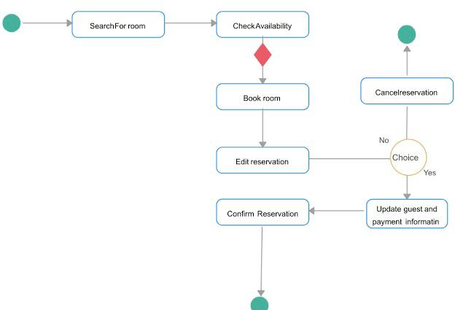**

**SEQUENCE DIAGRAM:**

**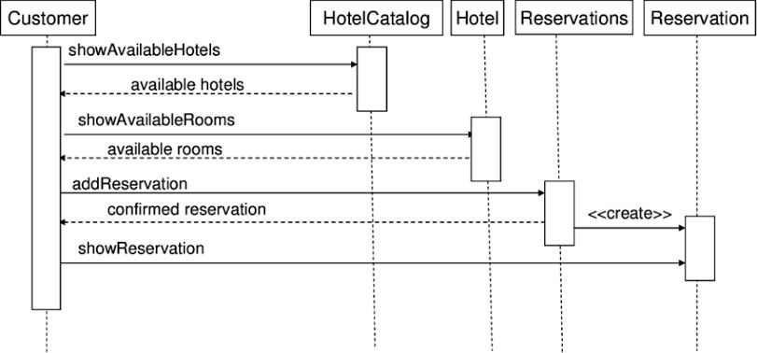**

**Referance:**

· [Hotelbeds APItude Hotels Suite](https://developer.hotelbeds.com/documentation/hotels/?utm_source=chatgpt.com" \t "_new)

· [SiteMinder's Hotel Reservation System Guide](https://www.siteminder.com/r/hotel-reservation-system/?utm_source=chatgpt.com" \t "_new)

· [Hotel Management System Project Documentation](https://www.studocu.com/in/document/acharya-nagarjuna-university/mca-ii-sem/hotel-management-system-project-documentation/41909511?utm_source=chatgpt.com" \t "_new)

· [Hotel Booking Management System Documentation](https://www.academia.edu/2112330/A_SAMPLE_HOTEL_MANAGEMENT_SYSTEM_PROJECT_DOCUMENTATION?utm_source=chatgpt.com" \t "_new)

**Conclusion:**

A hotel booking system plays a crucial role in streamlining the reservation process, enhancing customer experience, and improving operational efficiency. By automating key functions such as room availability checks, pricing management, and payment processing, the system eliminates manual errors and ensures seamless transactions.

Modern hotel booking systems integrate with various platforms, including websites, mobile apps, and third-party travel agencies, allowing hotels to maximize their reach and revenue. Advanced features like real-time inventory management, automated confirmation emails, and dynamic pricing adjustments further optimize the booking process.

Additionally, customer satisfaction is significantly improved through personalized services, easy booking modifications, and secure payment options. With data analytics and reporting capabilities, hoteliers can make informed decisions, predict demand, and strategize marketing efforts effectively.

In conclusion, implementing a robust hotel booking system is essential for maintaining competitiveness in the hospitality industry. It not only enhances guest convenience but also streamlines hotel operations, leading to increased efficiency, revenue, and overall business growth.